Monday | Tuesday | Wednesday | Thursday | Friday
Vegetables  Mashed Potatoes  Yoghurts  Jelly Pots  Watermelon  Muffins / Biscuits  Cake & Custard | Mashed Potatoes  Salad  Yoghurts  Jelly Pot  Watermelon  Muffin / Biscuits  Homemade Vanilla Sponge  Custard | Mashed Potatoes  Salad  Yoghurts  Jelly Pot  Watermelon  Muffins /Biscuits  Homemade Chocolate Brownies | Mashed Potatoes  Salad  Yoghurts  Jelly Pot  Watermelon  Muffin / Biscuits  Rice Krispie Traybake | Salad Selection  Mashed Potatoes  Yoghurts  Jelly Posts  Watermelon  Muffins / Biscuits
FLAVOURS OF THE WORLD
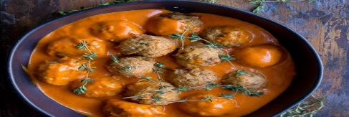 | 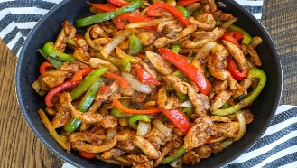 | 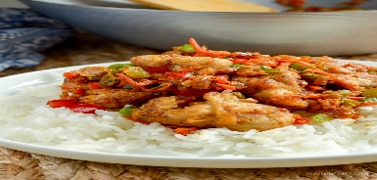 | 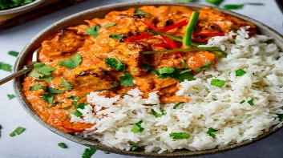 | 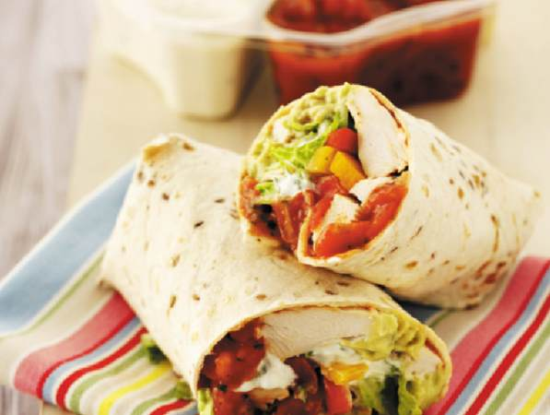
Monday | Tuesday | Wednesday | Thursday | Friday
Italian  Beef Meatballs and Red Pepper Sauce | Mexican  Spicy Chicken and Pepper Fajita | Asian  Salt & Chilli Chicken & Rice | Indian  Chicken Tikka Masala & Rice | Peri Peri  Peri-Peri Chicken Wrap
Holy Trinity College 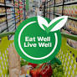
School Cash Cafe Lunch Menu - Week 1

GRAB & GO
Our Grab and Go selection features hot and cold options including fresh sandwiches, baguettes, rolls & wraps as well as burritos.

We also have fresh salad & pasta boxes and a selection of desserts from muffins and biscuits to hot sweet treats.

If you require any additional information on allergens or special diets, please contact your school.

