Monday | Tuesday | Wednesday | Thursday | Friday
Soup of the Day  Roast of the Day  Bolognaise  Savoury Mince  Hot Dogs | Soup of the Day  Chicken Goujons  Pizza  Chicken Curry & Rice  Chips | Soup of the Day  Hot-Dogs / Sausages  Irish Stew  Pork Chops  Chips | Soup of the Day  Roast of the Day  Cottage Pie  Lasagne  Chicken Crumble  Burgers | Soup of the Day  Fresh Fish  Oven Baked Sausages  Chips  Curry / Peppered Sauce
FLAVOURS OF THE WORLD
 | 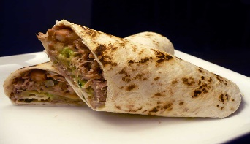 |  | 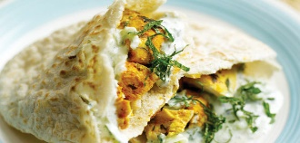 | 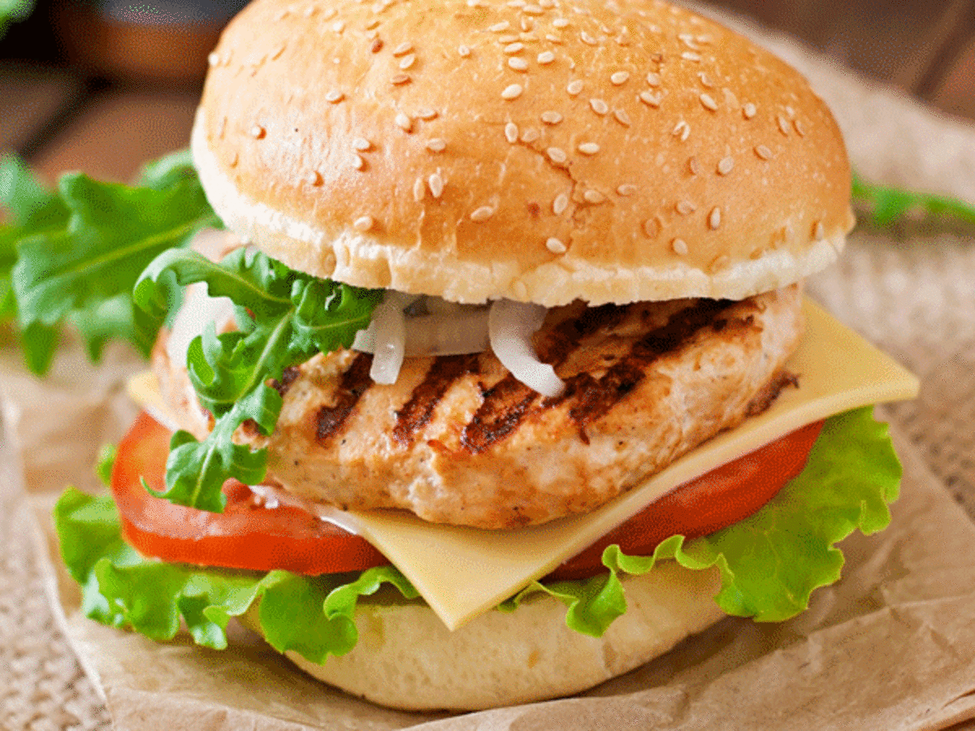
Monday | Tuesday | Wednesday | Thursday | Friday
Italian  Chicken Parmesan  Ciabatta Sandwich | Mexican  BBQ Pulled  Pork Burrito | Asian  Katsu Chicken Curry | Indian  Tandoori Chicken  Flatbread with Minted Yoghurt | Peri Peri  Baked Chicken  Burger with Peri-Peri Mayo
Holy Trinity College
School Cash Cafe Lunch Menu - Week 2

GRAB & GO | SOUP & SPUDS
Our Grab and Go selection features hot and cold options including fresh sandwiches, baguettes, rolls & wraps as well as burritos.  We also have fresh salad & pasta boxes and a selection of desserts from muffins and biscuits to hot sweet treats. | Why not try a bowl of our freshly made soup, with a tasty roll on the side.  We also have baked potatoes available with a variety of delicious fillings.  So much choice with Let’s Eat from EA Catering.

If you require any additional information on allergens or special diets, please contact your school.

